The Community Index of Issues and Solutions regarding Ball Pythons

CIISBP v.1.1.3.1.1

Maintained by [K. Catterall](https://github.com/Catterall).

See the end of the document for contributors.

Last revised 26th December 2022.

*Revision: removed benzalkonium chloride from listed issues*

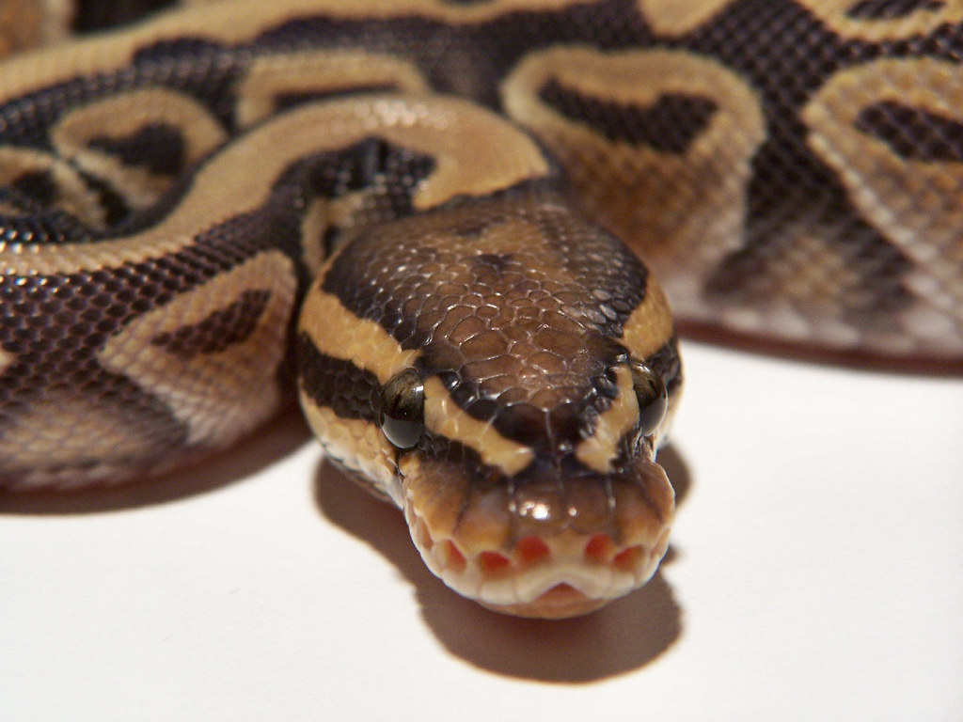

[This Photo](https://www.flickr.com/photos/alexbutler/439808645/) by Alex Butler is licensed under [CC BY-NC-ND (2.0)](https://creativecommons.org/licenses/by-nc-nd/2.0/)

**Contents**

**#1—Skin & Scale issues** 3

#1:1—Biological causes 3

#1:1:1—Scale rot dermatitis 3

**Contribution guide** 4

Document structure 4

Document versioning 4

Legalities 4

**Contributors** 5

# **#1—Skin & Scale issues**

## #1:1—Biological causes

### #1:1:1—Scale rot dermatitis

**Issue**:scale rot describes various dermatitis conditions in snakes, including vesicular dermatitis and blister disease. The most common cause of death regarding scale rot is septicemia. This occurs when bacteria enter the bloodstream of the snake [3].

**Symptoms**:

* Discolouration of the ventral scales (belly scales) [1] [2].
* Blisters and abscesses [2].
* Raised scales [2].
* Poor appetite [2].

**Causes**:

* Improper atmospheric conditions (humidity, temperature) [1] [2].
* Infected burns (often via unscreened floor heating) [1].
* Unclean enclosure [1] [2].
* Vitamin A or C deficiency [2].

**Solutions**:

* Remove the affected snake from its enclosure to an appropriately sized tub with newspaper bedding. Do not use the bedding from the enclosure. Disinfect thoroughly.
* Check and fix, if necessary, the atmospheric conditions of the enclosure.
* Sufficiently disinfect and clean the enclosure regularly. A typical disinfection rate is two months. Remember to spot clean efficiently between disinfections.
* Treat any wounds with a disinfectant and general skin medicine. For example, [Vetericyn Plus® Antimicrobial Reptile Wound and Skin Care](https://vetericyn.com/product/vetericyn-plus-reptile-wound-and-skin-care/).
* Take the affected snake to required veterinary services immediately if showing symptoms of septicemia or if the scale rot is beyond mild.

**Sources**:

1. [*https://www.msdvetmanual.com/multimedia/image/ulcerative-dermatitis-scale-rot-necrotic-dermatitis-ball-python*](https://www.msdvetmanual.com/multimedia/image/ulcerative-dermatitis-scale-rot-necrotic-dermatitis-ball-python)
2. [*https://vetericyn.com/blog/how-to-treat-scale-rot-on-reptiles/*](https://vetericyn.com/blog/how-to-treat-scale-rot-on-reptiles/)
3. [*https://www.petmd.com/reptile/conditions/cardiovascular/c_rp_septicemia*](https://www.petmd.com/reptile/conditions/cardiovascular/c_rp_septicemia)

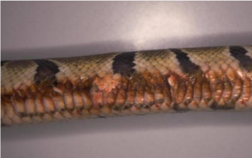

[This Photo](https://www.msdvetmanual.com/multimedia/image/ulcerative-dermatitis-scale-rot-necrotic-dermatitis-ball-python) by Dr Stephen Divers is licensed under [Unknown License](https://www.msdvetmanual.com/content/licensing)

# **Contribution guide**

## Document structure

When contributing to this document, please observe and follow the document structure as much as possible. [K. Catterall](https://github.com/Catterall) will revise your changes if necessary. However, at a minimum, you should include the following information:

* Issue: describe the issue you are documenting.
* Symptoms: list the symptoms of the issue: what are the visible effects of this issue?
* Causes: list any potential causes if no singular, proven cause exists. Otherwise, discuss the singular proven cause and how its implementation. If a cause is natural and has no remedy (e.g., “the snake is looking for a mate”), mark this cause in italics.
* Solutions: list any potential solutions if no singular, proven solution exists. Otherwise, discuss the singular proven solution and its implementation.
* Sources: provide links to any sources you have used to gather information. If your source is your personal experience, list it as experience, linking it to evidence of your experience.

The structure for documenting issues is $\#c:s:i$ where $c$ is the category index, $s$ is the subcategory index, and $i$ is the issue index. Each of these numbers should start at $1$ per higher index. In other words, $i$ should begin at $1$ for each index of $s$, and $s$ should begin at $1$ for each index of $c$.

Sources should be listed as a numbered list. The information documented from a particular source should reference the source number like this [n], where $n$ is the source number.

Write in US English.

## Document versioning

The version format for this document is $v.α.β.γ.δ.ϵ.$

* When changing the fundamental structure of the document, increment $α$.
* When adding or removing an issue category, increment $β$.
* When adding or removing an issue subcategory, increment $γ$. Ignore if $β$ incd.
* When adding or removing an issue to a subcategory, increment $δ$. Ignore if $γ$ incd.
* Following a minor revision, increment $ϵ$. If no revisions are present, it is $1$.

## Legalities

Please observe the following legal information.

* When showing images, add a caption linking to the image source, detailing the author, and linking to the image copyright. An example of these captions is on the front page of this document.

# **Contributors**

The following is a list of all individuals who have contributed to this document. **Neither this document nor its maintainer is responsible for any content its contributors produce**.

* [Catterall @ GitHub](https://github.com/Catterall)